PRODUCT AND CATEGORY MANAGEMENT
Project Title: Vilvah

1. Introduction
The Vilvah Natural Skincare and Personal Care Database Management System is designed to manage product and category information efficiently. The system uses related tables to store and organize product and category details. Primary key and foreign key constraints are used to maintain data integrity and establish relationships between the entities.
SQL operations such as INSERT, UPDATE, and DELETE are performed to manage product information. Category-wise reports can be generated using SQL to analyze products, prices, and stock information.

2. Objectives
- Design tables for Product and Category entities.
- Define primary key and foreign key relationships.
- Store product name, category, price, and stock details.
- Perform product insertion, updating, and deletion.
- Generate category-wise product reports.
- Maintain data integrity using constraints.

3. Relationship
The Vilvah database contains relationships between customers, products, categories, suppliers, orders, order details, payments and admins.
CUSTOMER (1) ─────────── (M) ORDER
SUPPLIER (1) ─────────── (M) PRODUCT
CATEGORY (1) ─────────── (M) PRODUCT
PRODUCT (1) ─────────── (M) ORDER DETAILS
ORDER (1) ─────────── (M) ORDER DETAILS
ORDER (1) ─────────── (1) PAYMENT
PRODUCT (1) ─────────── (1) INVENTORY
ADMIN (1) ─────────── (M) PRODUCT
ADMIN (1) ─────────── (M) ORDER

4.Table Design

4.1 Category Table
Attribute | Data Type | Constraint
Category_ID | NUMBER(10) | Primary Key
Category_Name | VARCHAR2(50) | NOT NULL, UNIQUE
Category_Description | VARCHAR2(200) | —
Status | VARCHAR2(20) | CHECK

4.2 Product Table

Attribute | Data Type | Constraint
Product_ID | NUMBER(10) | Primary Key
Product_Name | VARCHAR2(100) | NOT NULL
Category_ID | NUMBER(10) | Foreign Key
Supplier_ID | NUMBER(10) | Foreign Key
Price | NUMBER(10,2) | NOT NULL
Weight | VARCHAR2(20) | —
Ingredients | VARCHAR2(500) | —
Skin_Type | VARCHAR2(30) | —
Brand | VARCHAR2(50) | —
Expiry_Date | DATE | —

5. Table Creation

5.1 Create Category Table

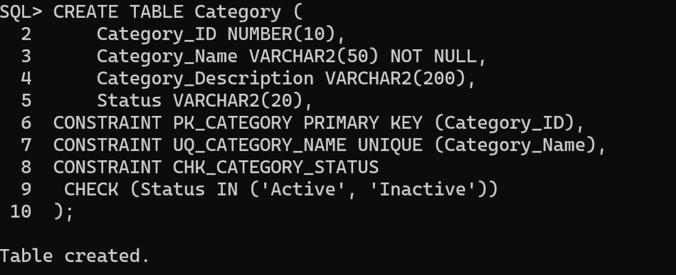

5.2 Create Product Table

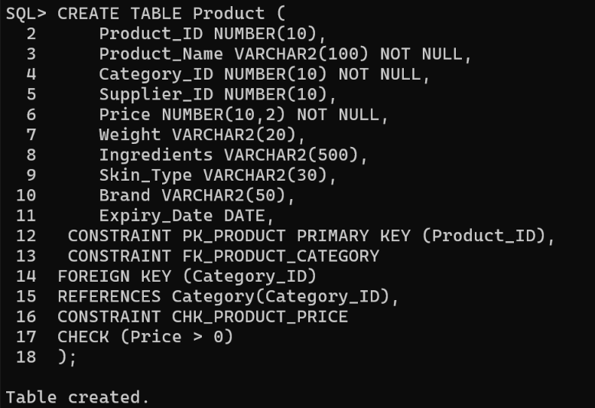

6 Data Insertion

6.1 Category Records

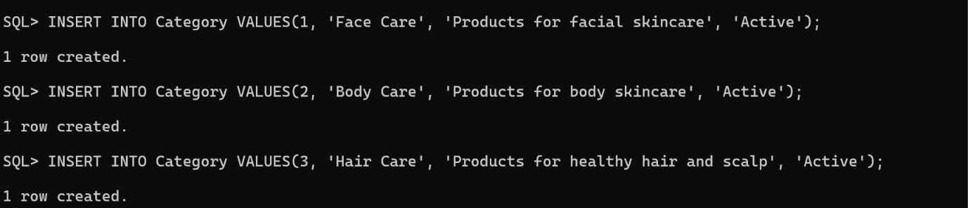
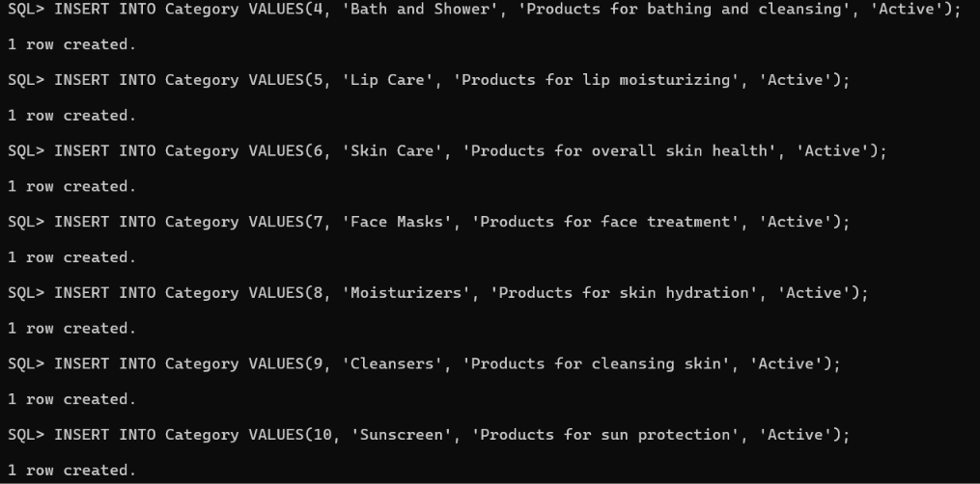

6.2 Product Records

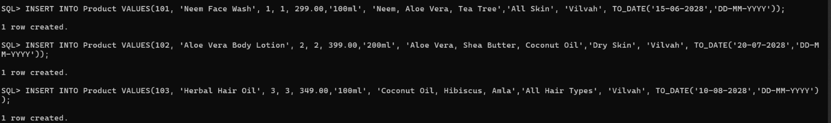
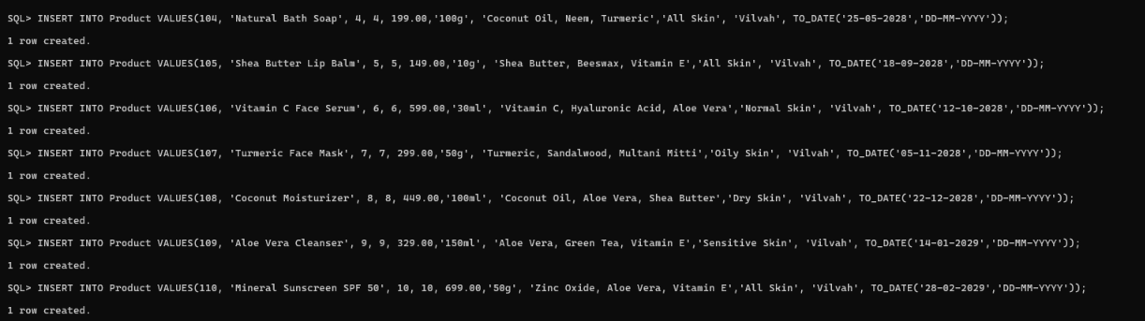

- Data Retrieval

  - Display Category Records

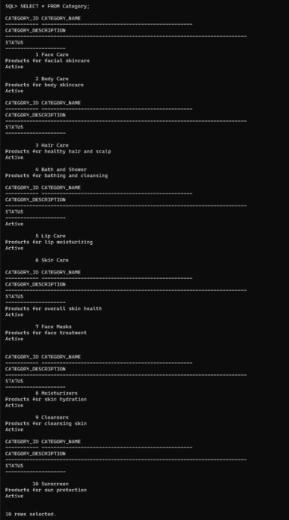

7.2 Display Product Records

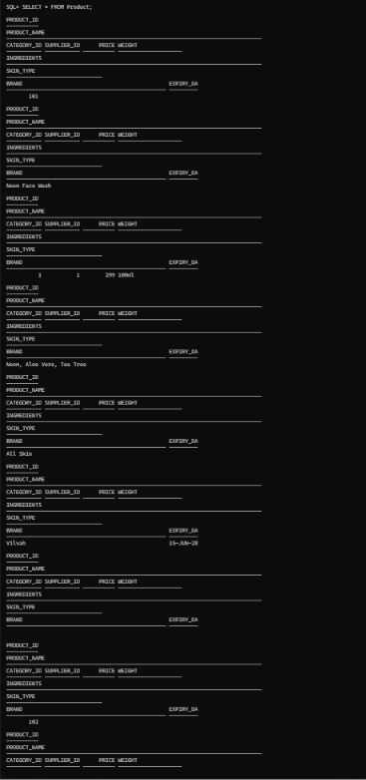
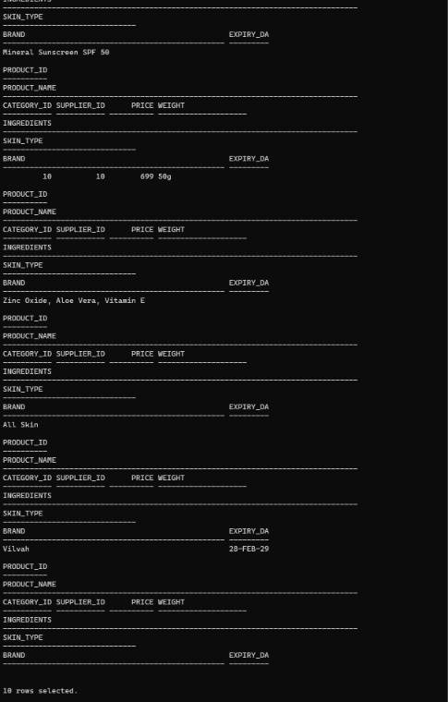

8. Product Update

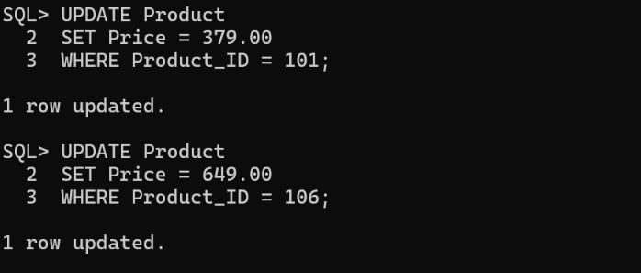

8.1 Product Deletion

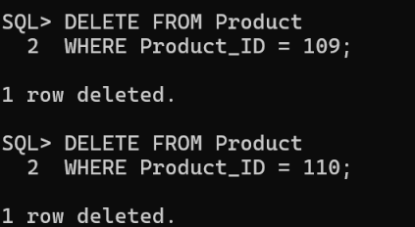

9.Category-wise Product Reports

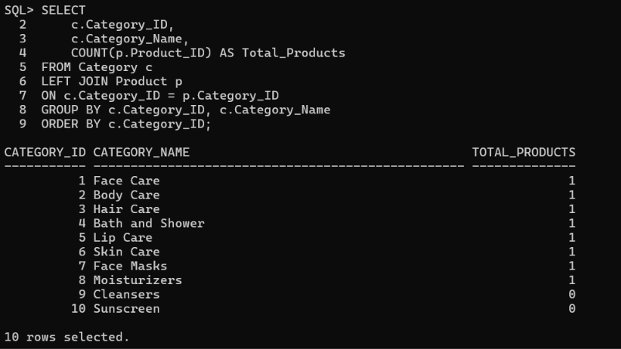

10. Product and Category Report

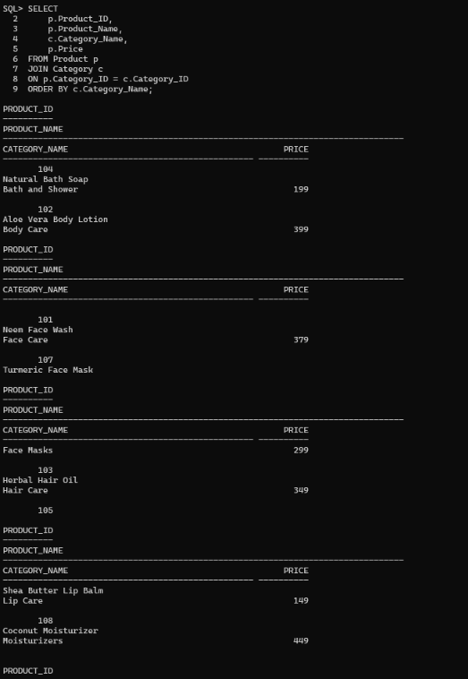
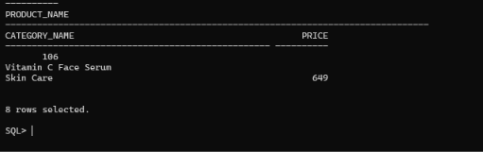

- Expected Category-wise Report

Category | Total Products | Total Stock
Bath and Shower | 1 | 60
Body Care | 1 | 40
Cleansers | 1 | 30
Face Care | 1 | 50
Face Masks | 1 | 25
Hair Care | 1 | 30
Lip Care | 1 | 45
Moisturizers | 1 | 40
Skin Care | 1 | 35
Sunscreen | 1 | 20
The report displays the number of products and total available stock under each category in the Vilvah product and category management system.
- Conclusion
The Vilvah Product and Category Management System successfully represents the relationships between customers, suppliers, categories, products, orders, order details, payments, inventory and admins.
Primary key and foreign key constraints help maintain data integrity and establish relationships between the tables.
INSERT, UPDATE and DELETE operations support effective product and category management. SQL reports provide useful information about products and stock, while PL/SQL programs can demonstrate procedural database programming for category-wise report generation and product price updates.

